Safety Data Sheet — Acetone 99.9%
Stroie Danut · Romania · masiniuneltedevanzare@gmail.com · +40 741 956 772
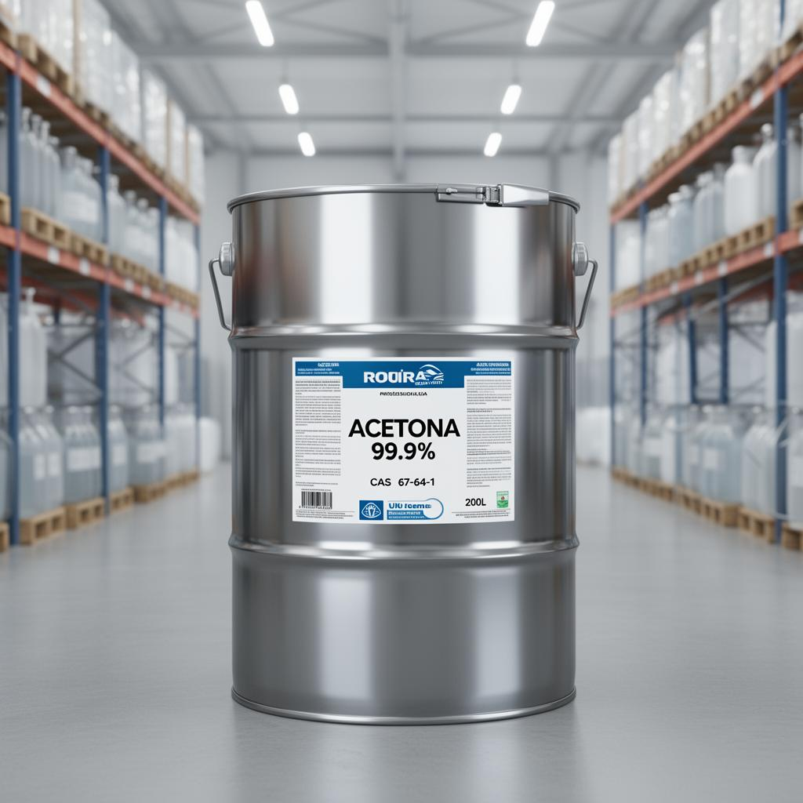

1. Identification
Product: Acetone 99.9% · CAS 67-64-1 · EC 200-662-2 · Formula C3H6O. Supplier: Stroie Danut, Romania.

2. Hazard identification
GHS02 Flame, GHS07 Exclamation. Signal word: DANGER. H225, H319, H336, EUH066.

3. Composition
Acetone ≥ 99.9% (CAS 67-64-1). Water ≤ 0.3%.

4. First-aid measures
Inhalation: Remove to fresh air. Skin: Wash with soap and water. Eyes: Rinse with water 15 min. Ingestion: Do NOT induce vomiting; seek medical attention.

5. Fire-fighting
Dry powder, CO2, alcohol-resistant foam. Do not use water jet. Flash point: -20 °C.

6. Accidental release
Eliminate ignition sources. Ventilate. Absorb with inert material. Avoid release into drains/water.

7. Handling & storage
Cool, dry, ventilated area. Away from oxidizers and ignition. Bonded/grounded transfer.

8. Exposure controls / PPE
OEL TWA 500 ppm. Use nitrile gloves, chemical goggles, anti-static clothing, vapor respirator if poorly ventilated.

9. Physical & chemical properties
Colorless liquid. Boiling 56 °C. Density 0.791 g/cm³. Soluble in water, ethanol, ether.

10. Stability & reactivity
Stable. Avoid strong oxidizers, bases, halogens.

11. Toxicological information
LD50 oral rat: 5800 mg/kg. Irritant to eyes and respiratory tract.

12. Ecological information
Readily biodegradable. Not classified as environmentally hazardous.

13. Disposal
Incineration in authorized facility per local regulations.

14. Transport
UN 1090, ADR Class 3, PG II, Label 3.

15. Regulatory
REACH registered. CLP classified. Listed on EINECS.

16. Other information
Issue date: 2026-05. Version 1.0. Stroie Danut, Romania.

